Date Deploy: 2014.04.07
Program: IBMSTC Return business, operation starts on 7th Apr 2014
- 2 storers created – IBMPDL and TGCS (Toshiba)

- Applicable to IBM STC accounts, Setup in WMS Storer.SiteCode = STC

User id for IBM reports: live_ibm
Password = l!v3_!bm

URL for external access is
http://livereports.schenker-ap.com/Reports

Reporting Tools: SQL2005 Business Intelligence/ Report Builder
Report Datasource: (IBMSD)
Data source=10.215.23.101;initial catalog=SCHPR_IBM_SD

Main Reporting manager
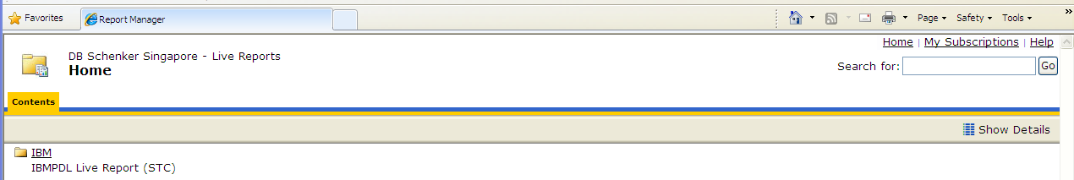

Reports
